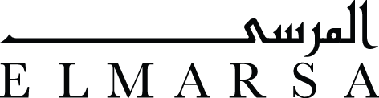
Ali Tnani
Unknown program
19 March | 26 April, 2018
Ali Tnani, Impersonal Memory, 2018, Drawings and mixed media installation, 120x80 cm
“An internet of things describes a world embedded with so many digital devices that the spaces between them consists not of dark circuity but rather the space of the city itself. The computer has escaped the box, and ordinary objects in space are carrier of digital signals.”
Keller Easterling, “An internet of things”, Eflux journal: the internet does not exist, (Berlin: Sternberg Press, 2015)
“When you ultimately succeed in listening to the place in its entirety, you will find that the distance between yourself and the space's sounds has diminished, and that you have become part of the place. You will find that no one around you notices your presence; everyone will pass by without seeing you.”
Haythem El-Wardany, How to disappear (Kayfa ta, 2013)
Elmarsa Dubai is pleased to present Unknown program, a solo exhibition of multimedia works by Tunisian conceptual artist Ali Tnani who offers an examination of social issues in post-revolutionary Tunisia through his multi-disciplinary practice that draws equally from installation as drawing, and photography, curated by Marie Cantos & Aziza Harmel.
Ali Tnani, Unknown Program, 2017, Drawing on paper, 30x40 cm
It is a well-known truth that the world is connected as never before. It therefore comes as no surprise that we are obsessively trying to keep up with a relentless flow of incoming data. Our efforts to do so are in vain, however information is somehow almost immediately neutralized or displays only a short term impact, due to the fluctuating nature of the internet. There are informational tombs, lost in the cyberspace. Ghosts that materialize in traces.
It is precisely this spectral trace around which Ali Tnani's exhibition Unknown program gravitates. Documents are artifacts or traces of human making, action, or thought surviving into the present. Monuments are documents that have a certain notion of urgency in our present and demand a recognition. Monuments are also related to an urgency in the past that we wish to evoke in order to remember or to neutralize the trauma that was caused.
The drawings, photographs and installations in this exhibition conjure up the document and the monument. Moreover they evoke the crossings and the traffic of what moves in the spaces between. These spaces are the artist’s materialized reflections on Other Spaces or what we could name Heterotopia. Heterotopia is a concept developed by Michel Foucault describing places that are simultaneously real and imaginary. These are spaces of an ambiguous utopia, with the ability to physically manifest.
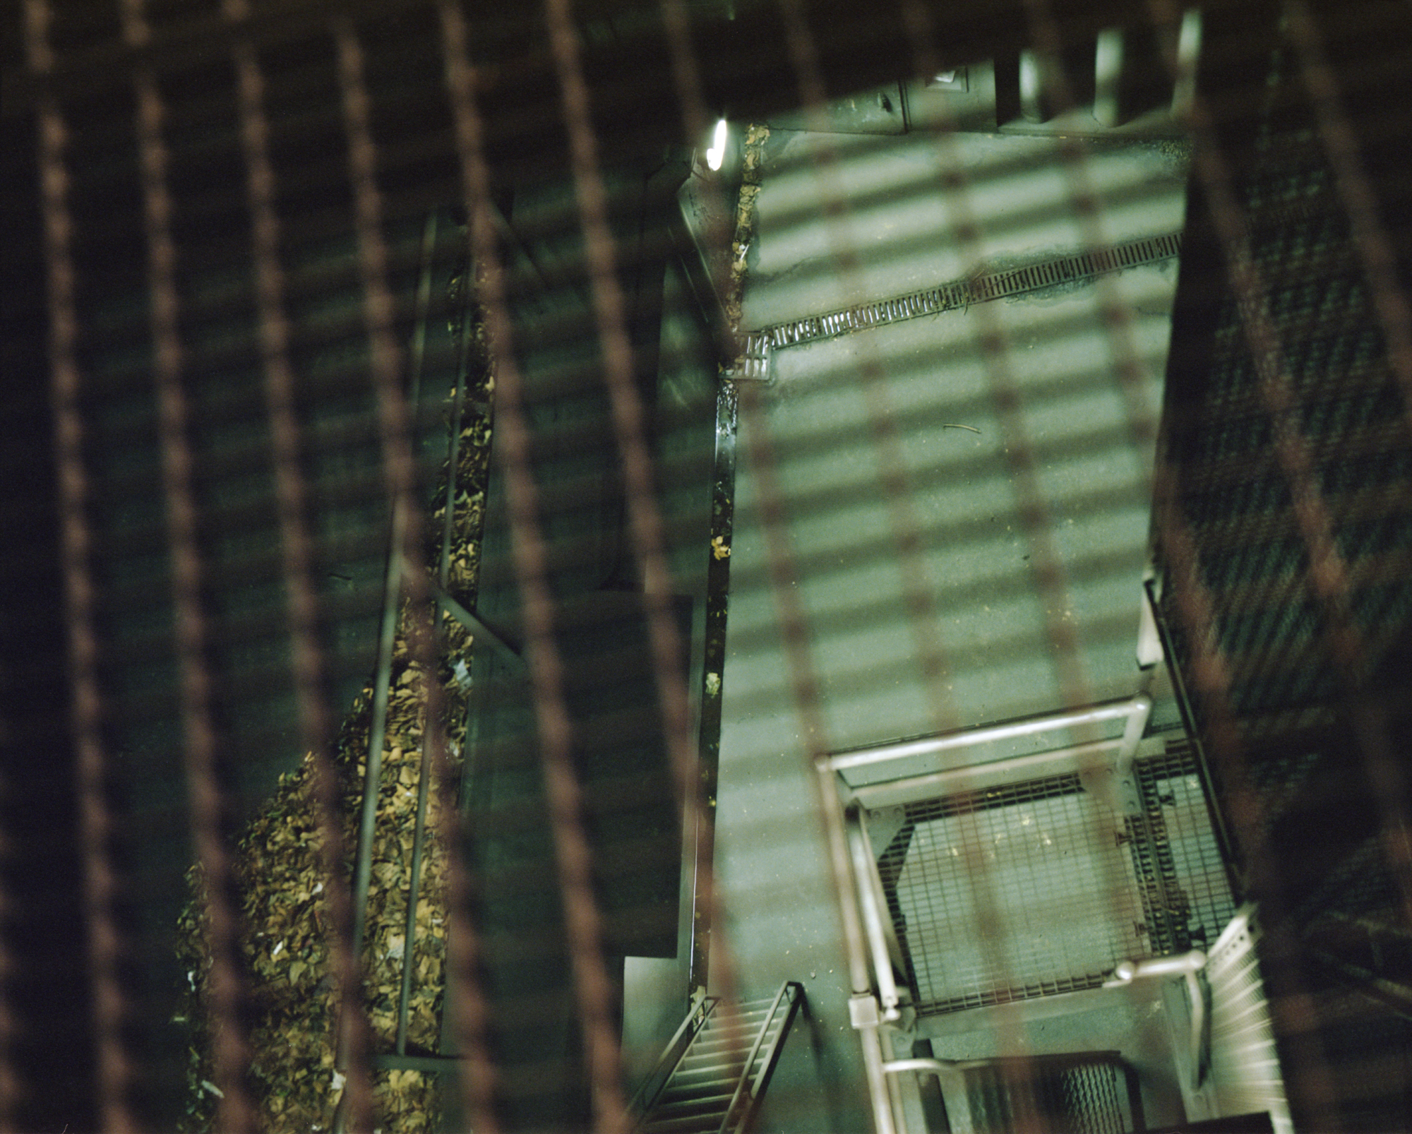
Ali Tnani, Others Spaces (8), 2017, Pigmented ink on Epson paper, 74x60 cm
In the photographs titled Other Spaces (2012), Tnani captured ventilation gates magically illuminated by an unknown source - suddenly made visible, yet out of reach and therefore beautiful. These spaces break with real time: they are suspended within a margin of our temporality.
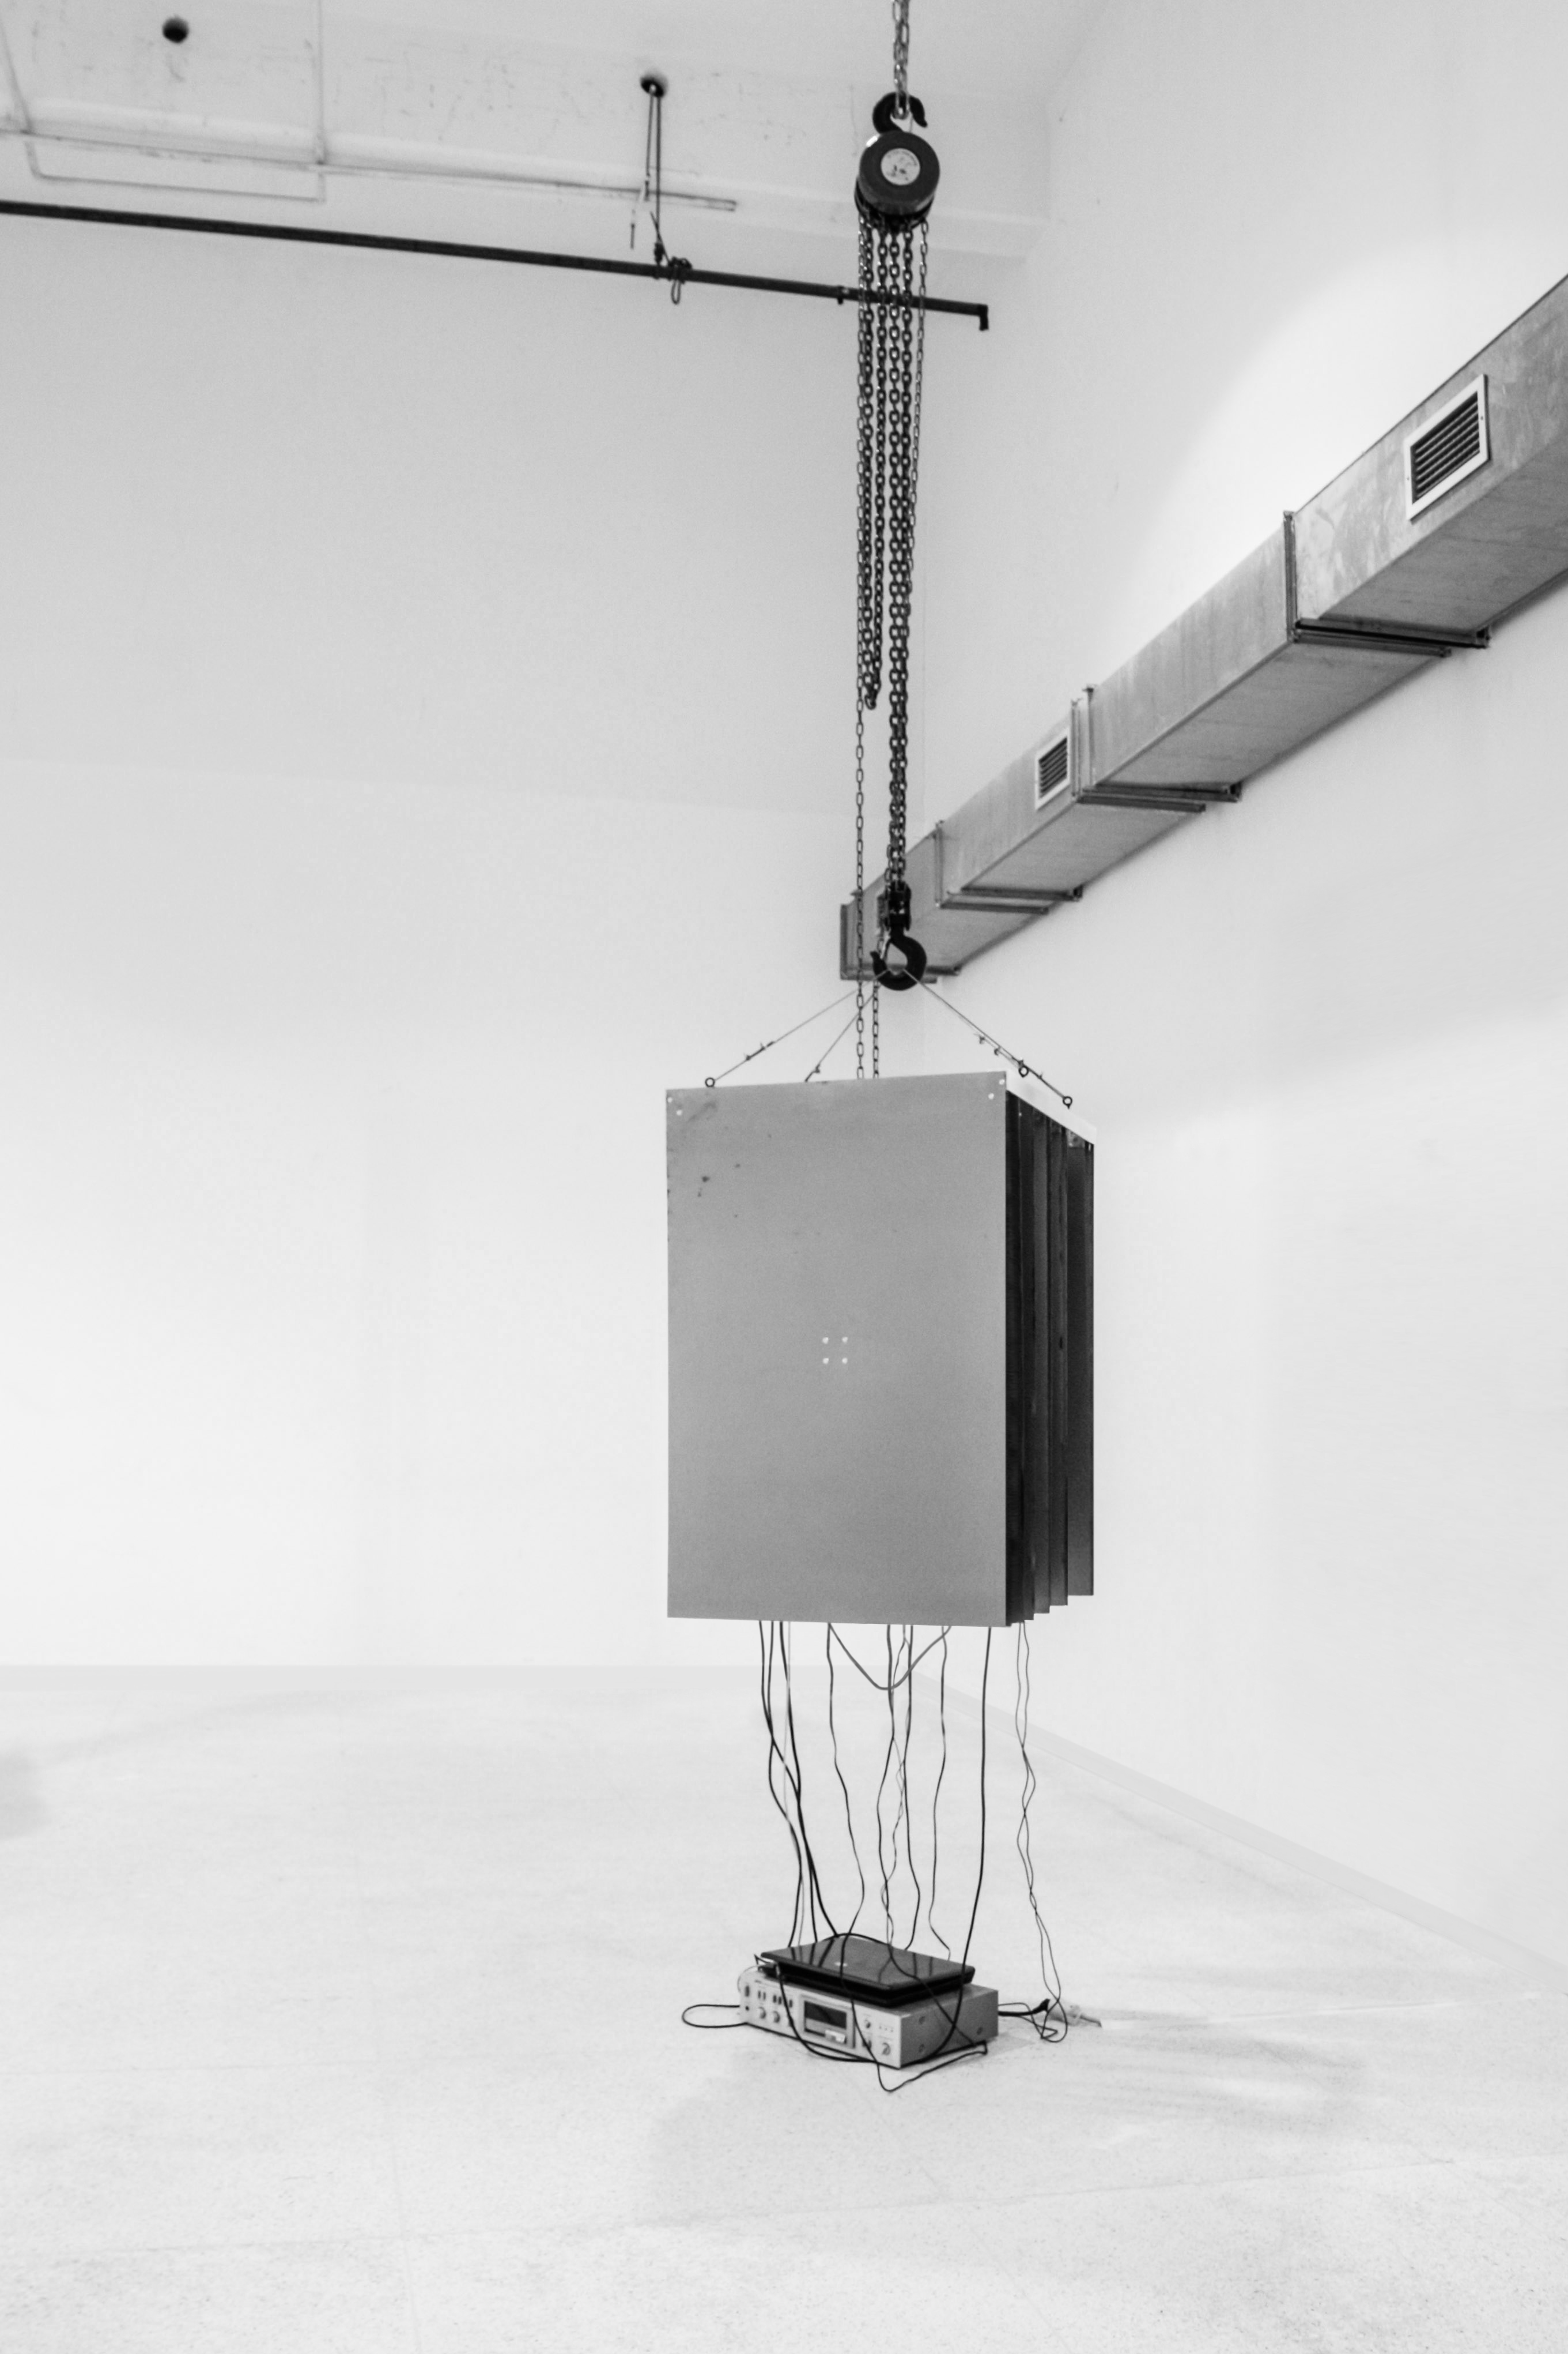
Ali Tnani, Crackling Data Machine, 2017, Mixed media installation, 85x100x66 cm
This suspension of time is also apparent in the rest of his work through the link between data and sound: data tend to vanish, while still defining the rhythm of our lives. The technological environment is much faster than our over-solicited cognitive responsiveness. In fact, the human brain can’t adapt to or expand beyond its organic nature, in order to keep up with the vertiginous rhythm of the information sphere. It is precisely this rhythm that the Crackling data machine (2014 / 2017) is offering resistance to. Realized in collaboration with the sound artist and composer Lukas Truniger, this strange instrument consists of a computer connected to the internet, a printer, suspended steel plates and a sound system. The information, randomly rendered from the internet, is printed and gathered into an absurd roll of paper full of cryptic information that becomes part of the sculpture. The movement of the printer creates a sound which translates the vertiginous speed of the information's flux into a slow jerky and spasmodic melody. A melody mostly defined by the silences in between, similar to the way Tnani's drawings are defined by the blanks and the empty spaces between remainder and erasure.

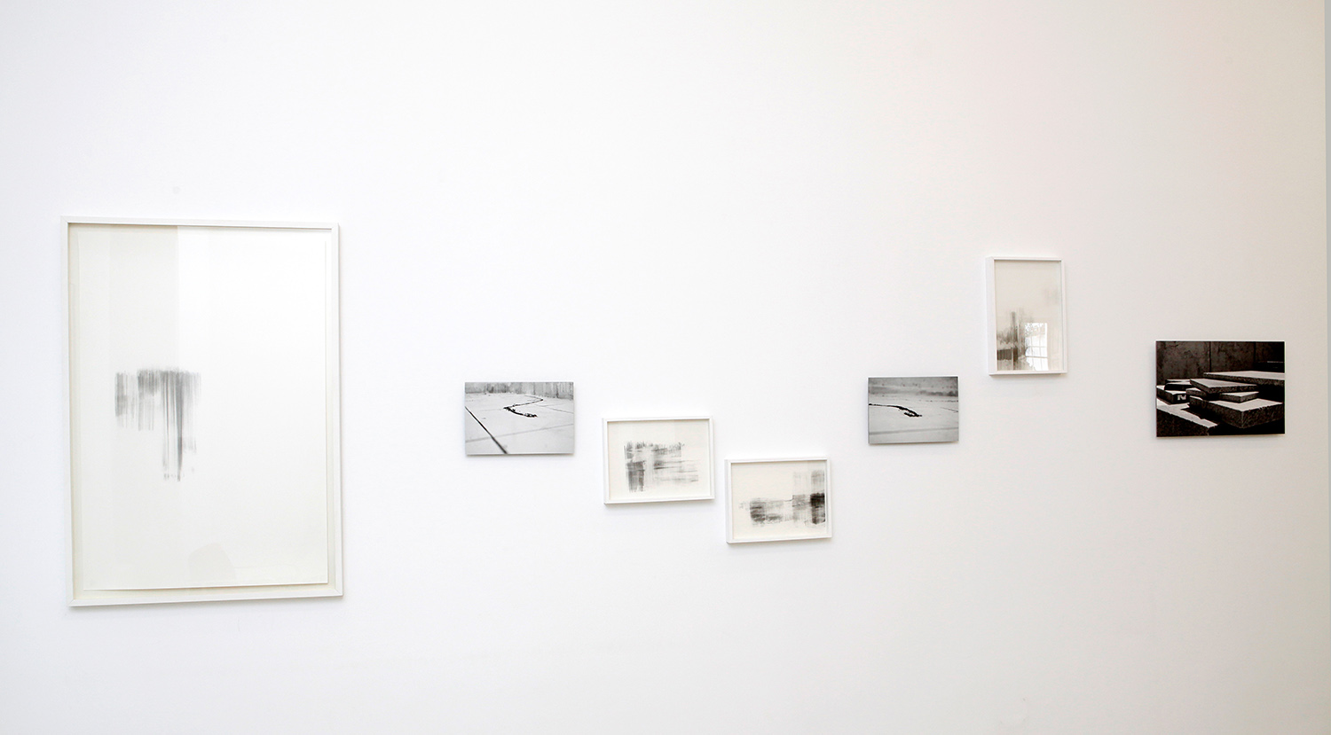
Ali Tnani, Space of exception (2014-2016), Drawing on paper and pigmented ink on fine art paper, variable dimensions - Installation view
His series of drawings Nécessité du monument (I&II) and Space of exception (2014-2016), are made out of traces of pigments and lead-mine residues, which create landscapes by vanishing from the surface of the paper. We are aware that something is missing: out of our reach or outside of our comprehension. Aside from their aesthetic purposes, these blanks also function as political spaces: they are the spaces to remember. Here, the border between documents and monuments gets blurred. Most of all, these spaces are an acknowledgment of the invisible.

Ali Tnani, Nécessité du monument II (Torbaa), 2017, Drawing on paper, 120x80 cm
Nécessité du monument II (Torbaa) is a series of drawings based on a photograph of the tomb of the artist's father, taken in order to remember the location of the monument. This notion of memory as a trace confronts us with the fact that every form of art must be impregnated by the latest (also past and coming) events. We are unable to forget, even though the monument we built is already a ruin.
As the exhibition unravels, the viewer discovers the presence of the remote: the remoteness of a trace that resists time, yet is unable to escape its destined disappearance. Nevertheless Ali Tnani's traces are more and more tangible. They escape their metaphorisation to enter the realm of social and subjective realities in the present.
Aziza Harmel, 2017

About the artist
Born in 1982 in Tunis, Ali Tnani is a Tunisian contemporary artist based in Tunis and Paris. He received his Masters in 2007 from the Institut Supérieur des Beaux-arts of Tunis and has since exhibited widely and participated in international residency programs like his two-year residency at the prestigious Cité Internationale des Arts in Paris.
A leading practitioner in the field of conceptual art, Tnani is known for his multimedia installation work examining social issues in post-revolutionary Tunisia. With a practice that draws on installation, drawing, and photography, he explores the question of erasure and the negative in narratives of traces, memory and history in an era of hyper-connectivity.
Tnani conceives the trace, as a semiotic index or remnant, an extension of his notion of “counter-spaces” that are simultaneously plastic and political. These sites shed light on the inherent contradictions and open a space for questioning hegemonic utopic narratives. These disruptive spaces expose the phantom signs of history in contemporary life: that which has been written, is being written and will be rewritten again in the future. Both material and immaterial form are visually reflected in his drawings where pigment and lead-mine residue seem to vanish into the surface of the paper.
He has participated in various exhibitions internationally, including the Musée du Bardo in Tunis, the Plateforme de création contemporaine in Paris, the Musée de Carthage in Tunis, the Musée des Beaux-Arts de Mons (Belgium) and the Musée du Montparnasse in Paris as well as the 13th edition of DAK’ART Biennial of Contemporary African art in Senegal, the 5th Marrakech Biennial and the Biennial of young artists from Europe and the Mediterranean in Skopje, Macedonia.
In 2017, he had his solo exhibition “Dans l'intervalle entre monument et document” at Elmarsa in Tunis, and “Unknown program” at Elmarsa in Dubai in 2018. His work is part of many private collections in Tunisia, France, USA, and the UK.

About Elmarsa
Elmarsa was founded in 1994 in Tunis and expanded to Dubai in 2015. Specialized in both modern and contemporary North African art, it represents recognized 20th century artists as well as mid-career artists. Elmarsa participates in several international art fairs in Dubai, Abu Dhabi, Paris, London, Marrakech, Miami and New York.
Exhibition Facts:
Opening Hours: Saturday – Thursday 10 am – 7 pm
Location: 23, Alserkal Avenue, Al Quoz 1, Dubai, UAE
Contact: +971 43415806│info@galerielmarsa.com
Website: galerielmarsa.com
For press information and images:
Hanya El-Azzouni
Sharon George
info@galerielmarsa.com
+971 43415806
2 place du Saf Saf  2070 La Marsa, Tunisia  T: 216-71-740572 | 23, Al Serkal Avenue  Al Quoz 1, Dubai, UAE  T: 971-4-3415806
www.galerielmarsa.com

