Baya Mahieddine (1931-1998)
18 May – 15 July, 2019
Alserkal Avenue, Dubai
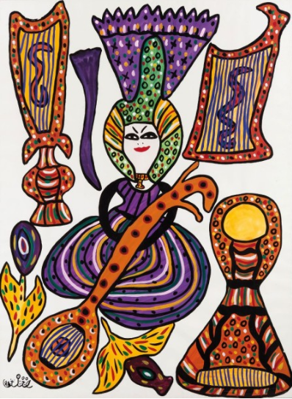
Baya (1931–1998)
Femme au oud et à la cithare, 1984, Gouache on paper, 100x75 cm
Elmarsa Gallery in Dubai is pleased to present the exhibition of the work of self-taught Algerian artist Baya Mahieddine known as Baya. On view from March 18 through June 15, 2019 at Alserkal Avenue, the exhibition Baya Mahieddine (1931–1998) comprises some 15 gouache paintings that shed light on Baya’s groundbreaking career as the most famous Algerian woman artist. This second show of the artist organized by the gallery draws attention to Baya’s profound influence on North African post-colonial art movements during the mid-twentieth century and beyond. With artists like M’Hamed Issiakhem (1928-1985), Abdelkader Guermaz (1919-1996), Mohammed Khadda (1930-1991), Baya is among the most important and influential artists in Algerian modern art, and, like Frida Kahlo, was often associated with the Surrealist movement. Baya took her inspiration primarily from her homeland where she died in 1998. Her dreamlike quality work, rich in symbols and ornamentation was clearly influenced by her Algerian cultural heritage.
Orphaned at age five, Baya was drawn to art as an adolescent by observing what she lived with and saw all around her, a mix of Arab and Berber cultures. Baya was highly valued by many of the leading figures of the Parisian avant-garde such as Pablo Picasso, Henri Matisse, and the father of Surrealism, André Breton, who exclaimed enthusiastically: “Baya is queen” in his writings on the young talented Algerian woman. Celebrated in Algeria, France, and the Middle East, Baya gained international recognition with the first North American exhibition organized by the Grey Art Gallery at New York University in 2018.
About Baya
Born in Bordj el-Kiffan in 1931, self-taught Algerian artist Baya Mahieddine, known as Baya, was orphaned at age five living with her father’s family. Later in 1940, she was adopted in Algiers by the French art collector, Marguerite Camina Benoura, formerly married to the British painter Franck Mac Ewen. Encouraged by her adoptive French parents, living in Algeria, to pursue art (although she remained illiterate), she was exposed to Benoura’s collection of modern art, including works by Matisse, and by age nine she was painting and sculpting in clay as well. Her work was soon discovered by the sculptor Jean Peyrissac and legendary French gallerist Aimé Maeght, known for representing Miro, Calder, Leger, Braque, Giacometti and Chagall, who invited her to exhibit for her first solo show in his gallery in Paris in 1947, at the age of sixteen. Andre Breton wrote the preface to the Galerie Maeght’s catalogue. The prestigious publication “Derrière le Miroir” was consecrated to Baya, with texts by Jean Peyrissac and Emile Dermenghem. The colorful, surreal and childlike imagery of her work appealed to leading Parisian figures, including Pablo Picasso, with whom she collaborated in the renowned Madoura ceramics studio in Vallauris in 1949, and traces of her influence can be seen in his Women of Algiers series. Baya and Jean Senac meet up in Algiers. Together, they translated and illustrated poems such as “bwaqel” which were published in Senac’s literary collection “Soleil”. Her work was featured in prestigious publications such as the magazine “Vogue” that consecrated the cover page to her with a text by Edmonde Charles Roux.
In 1953, she married the musician El Hadj Mahfoud Mahieddine and raised a family during a time of revolution in Algeria, but declined an offer to move to France, in affirmation of her Algerian identity. She settled with her family in Blida in Algeria: it's the end of an era. Thanks to the praises of Jean de Maisonseul, who was the director at the Fine Arts National Museum, Baya returns to her studio after a break of ten years. She exhibited in 1963 at the Fine Arts National Museum of Algiers and in 1964 in Paris. She won the 2nd prize of the National Union of Visual Arts (UNAP) in 1971. In 1982, the Museum Cantini in Marseilles organized an exhibition of her work inaugurated by French President François Mitterrand in presence of the Mayor of Algiers and the Minister of Culture, Jack Lang. Baya’s work has been regularly exhibited in Paris in 1984, 1987 and 1991. In 1986, she participated at the 2nd Biennial of La Havana, Cuba. In July 1987, she was honored by Algerian president Chadli. Since 1980, Baya has been suffering from a serious disease and she died on November 9, 1998. A portrait of Baya and one of her paintings appeared on Algerian postage stamps in 2008. Celebrated in Algeria, France, and the Middle East, Baya gained international recognition with the first North American exhibition in 2018, “Baya: Woman of Algiers” organized by the Grey Art Gallery at New York University. Her works can be found in numerous public and private collections worldwide.
About Elmarsa
Elmarsa was founded in 1994 in Tunis and expanded to Dubai in 2015. Specialized in both modern and contemporary North African art, it represents recognized 20th century artists as well as mid-career artists. Elmarsa participates in several international art fairs in Dubai, Abu Dhabi, Paris, London, Marrakech, Miami and New York.
Gallery Information
Opening Hours: Monday – Thursday: 10am – 7pm, Saturday: 10am – 6pm
Location: Unit 23, Alserkal Avenue, Al Quoz 1, Dubai, UAE
Gallery Contact
Sharon George
+971 43415806 │info@galerielmarsa.com

www.galerielmarsa.com
2 place du Saf Saf  2070 La Marsa, Tunisia  T: +216 71740572 | 23, Alserkal Avenue  Al Quoz 1, Dubai, UAE  T: +971 43415806

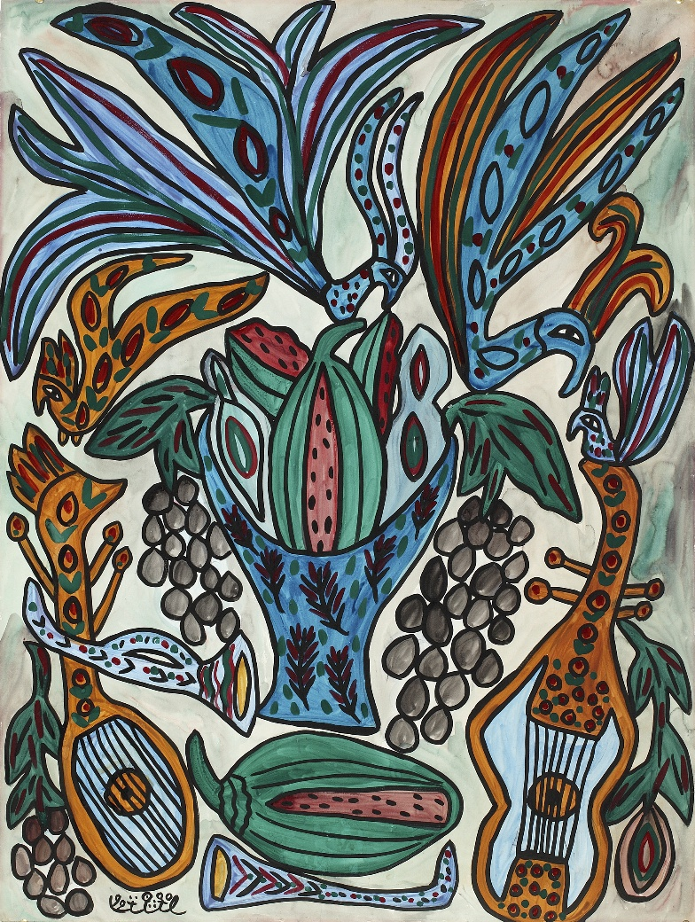
Baya, Nature morte avec mandores (Vase bleu), 1990
Watercolour and gouache on paper, 99 x 75 cm
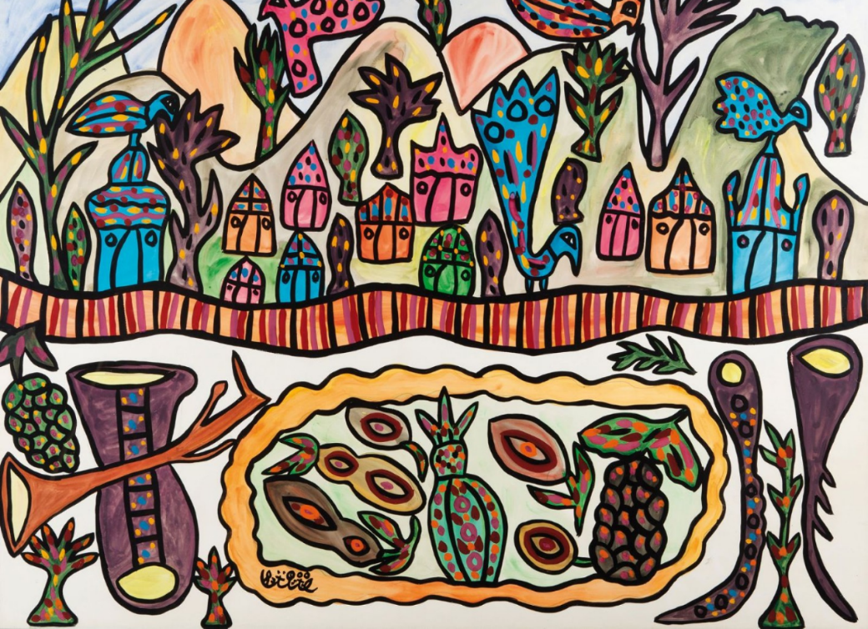
Baya, Village aux oiseaux, 1987, Gouache on paper, 75x100 cm

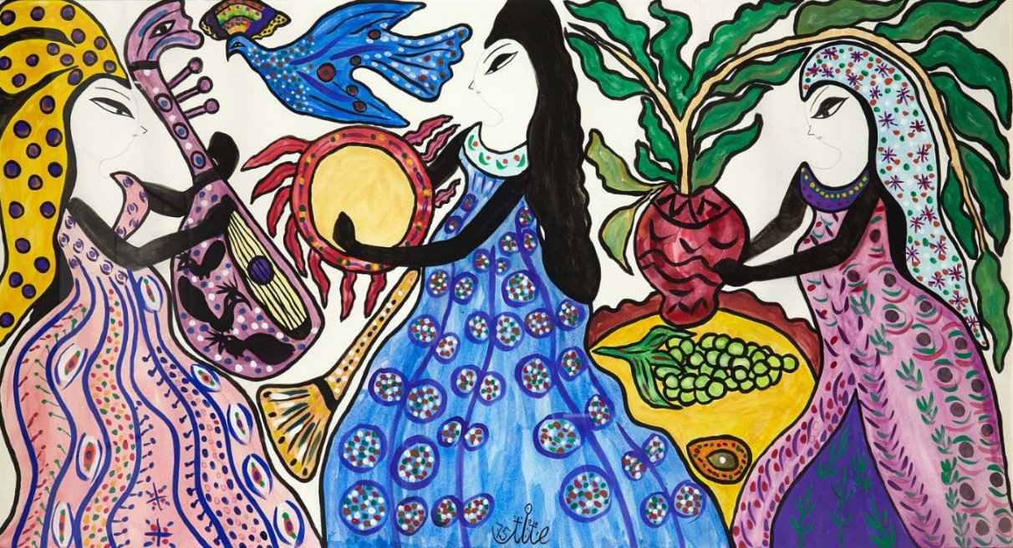
Baya, Musiciennes, 1975, Gouache on paper, 80.5 x 148.5 cm

